Sumi Choudhury HW #5

SDGB 7844 December 7, 2016

Solutions HW 5

1) For the reduced data set, we have:

Start date: 2003-01-08

End date: 2014-10-29

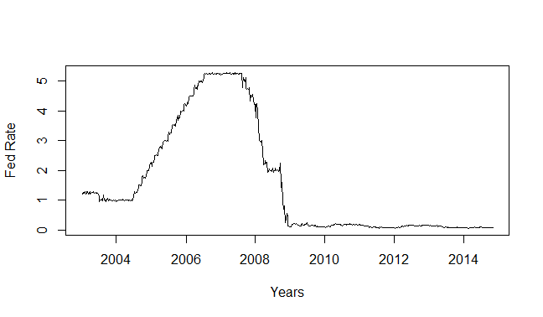

Between 2004 and 2006, the Fed increased the risk free rate rapidly because they were uncomfortable about the growing inflation rate. Inflation did not seem to respond to the rising interest rates. However, between 2007 and 2008 during the global financial crisis, the Fed had to quickly respond by rapidly lowering interest rates, thus there is a sharp drop in the Fed Rate for that period. The Fed dropped interest rates in an effort to spur economic activity and growth, so that with lowered interest rates, consumers would borrow more, spend more and increase the money supply in the economy.

2) Number of observations in training set: 570

Number of observations in test set: 43

3) S&P Returns:

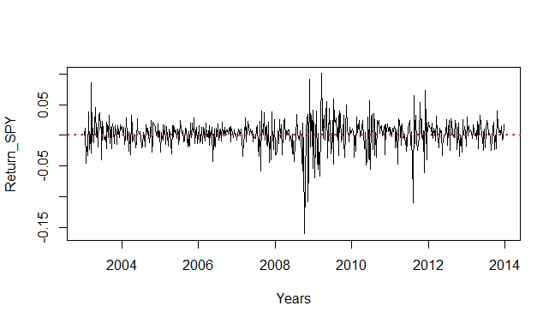

TLT Returns:

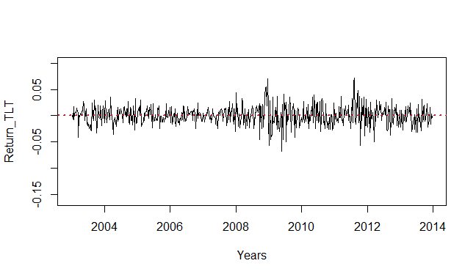

The returns for S&P 500 have a greater variation than the returns for Long-Term Treasury Bonds. Both have negative as well as positive returns. Both appear to have higher volatility during the financial crisis period.

4)

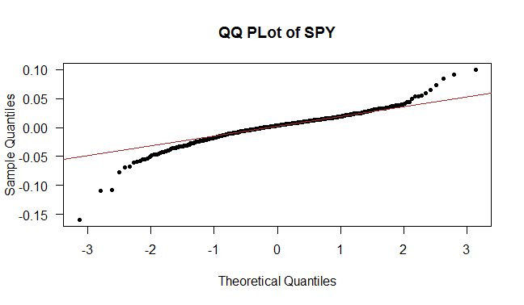

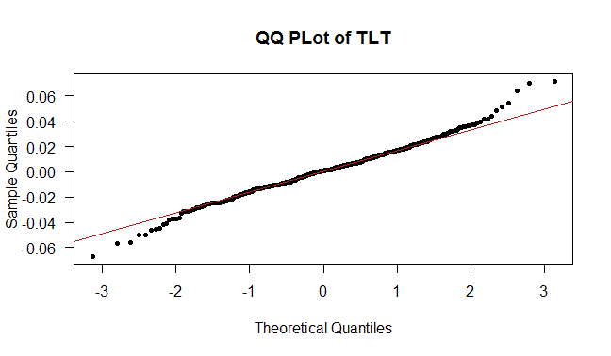

The assumption of normality does not seem to be satisfied. In the distribution of SPY, we can see that the distribution is not normal. This is evident in the s-shaped curve of the plot. In the distribution of TLT, we can see that the distribution is not normal due to the tail ends of the plot, which indicate that the distribution likely has heavy tails. For data sets with a large number of observations, if we were to conduct a test for normality, we may even sometimes fail to reject the null hypothesis that the distribution is not normal. However, this type of analysis while statistically significant may not be practically significant. For large samples, the sampling distribution tends to be normal so we may ignore the distribution of the data. Yet we note that, with financial data this assumption can be violated even with a large sample size.

5) The correlation value between S&P returns and Long-Term Treasury Bond returns is

-0.3438971. This implies a moderate negative correlation between the two returns. This means that when S&P returns increase, Treasury Bond returns tend to decrease, and vice versa.

The scatterplot is shown below:

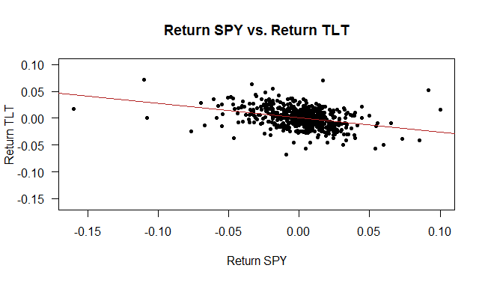

Rolling-Window Correlation Time Series Plot (end of each rolling 24 week period):

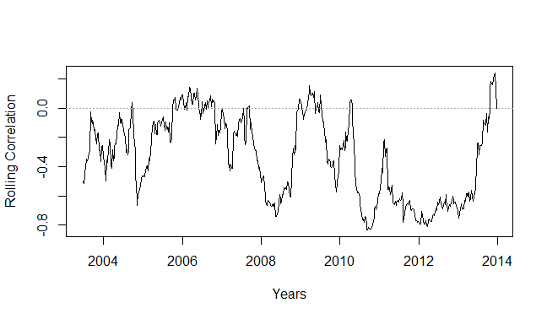

With the rolling-window correlation, we can see the correlation with a greater frequency of time and shorter continuous intervals. This is better than the simple correlation because it shows that external factors might be present at some point of time which affect the relationship between the S&P 500 returns and the Long-Term Treasury Bond returns.

6) The Sharpe ratio is the average return earned in excess of the risk-free rate per unit of volatility or total risk. In other words, the idea of the ratio is to see how much additional return you are receiving for the additional volatility of holding the risky asset over a risk-free asset. The higher a fund’s Sharpe ratio, the better a fund’s returns have been relative to the risk it has taken on. Because it uses standard deviation, the Sharpe ratio can be used to compare risk-adjusted returns across all fund categories. In this case, the Sharpe ratio for the S&P 500 is 0.2807176 or 28.07%. The Sharpe ratio for Long-Term Treasury Bonds is -0.01095925 or -1.01%. The results indicate that the S&P 500 is a better investment because of the higher Sharpe ratio, meaning higher standard returns over the risk-free rate per unit of volatility.

7)

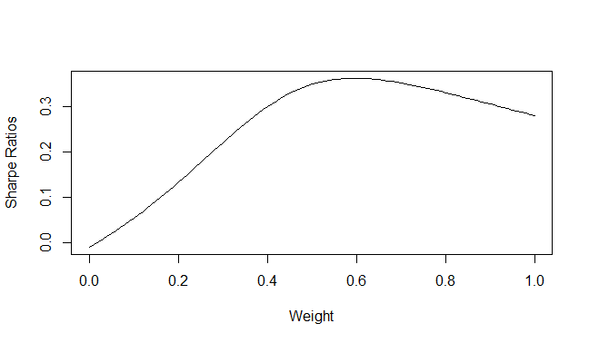

A portfolio weight of near 0.6 will produce the maximum Sharpe ratio.

8) The S&P 500 should have 59.585% of funds allocated and the Long-Term Treasury Bonds should have 40.415% of funds allocated. The Sharpe ratio for the overall portfolio is 0.3634139, meaning that it has an overall risk adjusted return per unit of volatility of 36.34%. The combined portfolio performs better than each of the funds individually (as shown in question 6), so it is better to invest in the combined portfolio.

9)

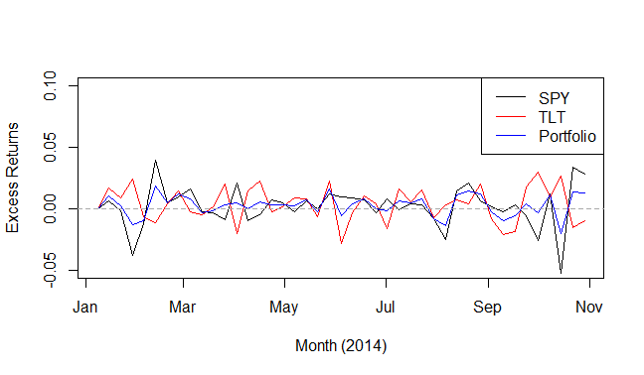

The excess returns for the combined portfolio is consistently in between excess returns for the S&P 500 and the Long-Term Treasury Bonds. It is less volatile than the S&P 500, so it provides less losses but at the same time less gains than the S&P 500. The combined portfolio shows greater losses but also higher gains than the Long-Term Treasury Bonds.

10) According to the results, investing $100 in each asset in the first week of January 2014, at the end of the test period we would have the following excess returns:

S&P 500: $2.811

Long-Term Treasury Bonds: -$1.004

Combined Portfolio: $1.269

In the test, the combined portfolio did not perform as well as the S&P 500, but performed better than Long-Term Treasury Bonds. This is most likely due to the current state of the economy at the time of the investments. Although combined porfolios of safer Treasury Bond investments and riskier stock market investments can provide a better return at times, in this case the fed rate is much lower in 2014, allowing for greater excess returns overall. It can be noted that here we are measuring the returns in excess of the risk-free rate. So, the S&P 500 appears to perform better. However in the previous example, where we calculated the Sharpe ratio, we measure the excess return per unit of volitility. So, the combined portfolio performs better when we take into account the volitility.

> print(Test_Set$Et_SPY[43]*100)

[1] 2.811077

> print(Test_Set$Et_tlt[43]*100)

[1] -1.004466

> print(Test_Set$Et_Portfolio[43]*100)

[1] 1.269026